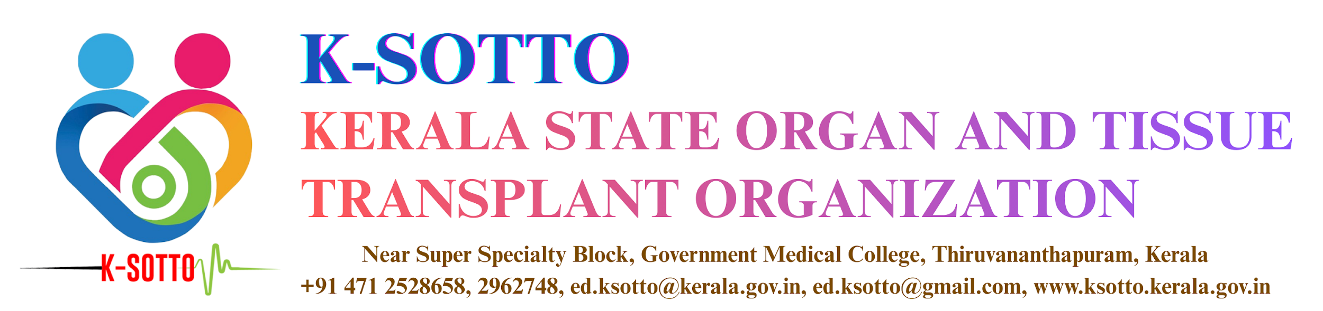
LIVER SUPER URGENT LISTING - PROFORMA FOR REPORTING
(Responses to Questions 1–15 are mandatory.
If any specific data field under the relevant category is not applicable, please indicate it as “NA.” )
Basic Information
01. Hospital Name:
02. Patient Name:
03. DOB: 04. Gender:
05. K-SOTTO Recipient Reg. No:
(If not registered please specify reason)
06. Contact number of patient relative:
07. Address:

08. Blood Group & Rh:
09. Nationality:
10. Duration of onset of current episode of illness:
- <1 week
- 1-2 weeks
- >2 weeks
11. If patient has undergone a liver transplant any time earlier, mention date or month and year of transplant as available:
12. If patient has undergone a liver donation surgery any time earlier, mention date or month and year of surgery as available:
13. Please state the category under which the patient meets the listing criteria:
14. Name of treating transplant consultant:
15. Date & Time of raising listing request:

Please enter the specific information for the category under which the patient meets the super urgent liver listing criteria for review by the liver sub-committee
(if any specific data field in the concerned category is unknown mention ‘NA’)
Etiology: Paracetamol Poisoning
Category 1:
pH:
Date and time of diagnosis (if referred from another hospital, date and time at which diagnosis was made at the referring hospital may be mentioned):
Fluid resuscitation:
- Normal saline: YES/NO
- Ringer lactate: YES/NO
- Dextrose: YES/NO
- Others if any:
Category 2:
Prothrombin time: INR:
Serum creatinine (mg/dl): Urine output 24hrs:
Grade of encephalopathy:
Category 3:
Fluid resuscitation:
- Normal saline: YES/NO
- Ringer lactate: YES/NO
- Dextrose: YES/NO
- Others if any:
Arterial lactate on admission (mmol/l): Date & Time of testing:
Arterial lactate at 24hrs (mmol/l): Date & Time of testing:
Could you exclude other causes of hyperlactemia (e.g. pancreatitis, intestitial ischemia): YES/NO
Grade of encephalopathy:
Category 4:
Prothrombin time: INR:
Serum creatinine (mg/dl): Urine output 24hrs:
Grade of encephalopathy:
Intra cranial pressure (mmHg):
FiO2:
Inotropes:
Are there any signs suggestive of clinical sepsis: YES/NO

Etiology: Seronegative Hepatitis, Hepatitis A, Hepatitis B, Idiosyncratic Drug Reaction.
Category 5:
Etiology:
Hepatic encephalopathy: Absent/ Present
Age of the patient:
Prothrombin time:
INR:
INR (post Vitamin K repletion):
Day of onset of jaundice:
Day of onset of encephalopathy:
Serum bilirubin (mg/dl):

Etiology: Acute Viral Hepatitis: Hepatitis A, Hepatitis B
Category 6:
Etiology:
Grade of encephalopathy:
Prothrombin time: INR:
Age:
Date of onset of jaundice:
Date of onset of encephalopathy:
Serum bilirubin (mg/dl):
Etiology: Acute presentation of Wilson’s disease, auto-immune hepatitis or Budd-Chiari syndrome
Category 7:
Etiology:
Prothrombin time: INR:
Grade of encephalopathy:
Etiology: Hepatic artery thrombosis
Category 8:
Date of liver transplant surgery:

Etiology: Early allograft dysfunction
Category 9:
Date of liver transplant surgery:
AST:
INR:
Arterial lactate (mmol/l):
Bile production absent: YES/NO
Etiology: Total hepatectomy patient
Category 10:
Reason for total hepatectomy:

Etiology: Severe liver failure within 4 weeks post liver donation surgery
Category 11:
Date of liver donation surgery:
Etiology: Acute liver failure in children under 2 years of age
Category 12:
INR:
Grade of encephalopathy:
Etiology: Yellow phosphorus (Ratol poisoning)
Category 13:
Prothrombin time:
INR (post vitamin K repletion):
MELD Score:
Grade of encephalopathy:
Is the patient on plasmaphereses: YES/NO
If yes, INR (12 hours after second set of plasmaphereses):

