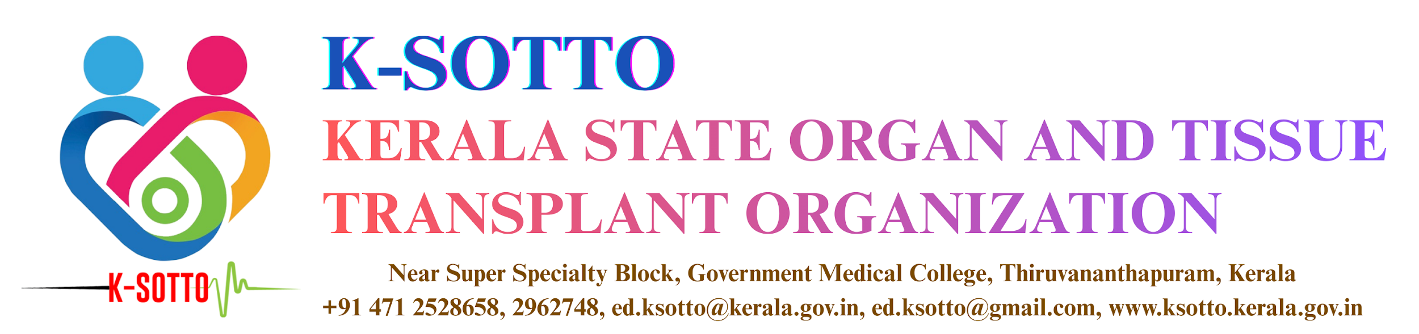
CRITERIA LISTING FOR SUPER URGENT LIVER TRANSPLANTATION
PARACETAMOL POISONING
Category 1
- pH<7.25 more than 24h after overdose and after fluid resuscitation
Category 2
- Co-existing prothrombin time >100s (or) INR >6.5
and
- serum creatinine >3.4mg/dL (or) anuria: 24hr urine output <100ml,
and
- Grade 3–4 encephalopathy
Category 3
PREREQUISITES: adequate fluid resuscitation, and exclusion of other causes of hyperlactemia (e.g. pancreatitis, intestitial ischemia)
- Arterial lactate >5mmol/L on admission
and
- >4 mmol/L 24h later
and
- Clinical hepatic encephalopathy
Category 4
PREREQUISITES: Absence of clinical sepsis
(Any two from the below 1, 2 and 3 & features suggestive of deterioration from 4, 5 and 6)
1. Co-existing prothrombin time >100s (or) INR >6.5
and
2. Serum creatinine >3.4mg/dL (or) anuria: 24hr urine output <100ml,
and
3. Grade 3–4 encephalopathy
4. Increased Intra cranial pressure
5. Fi0₂> 50%
6. Increasing inotropes
UNFAVORABLE ETIOLOGIES
Seronegative hepatitis, idiosyncratic drug reactions, drug-induced liver injury.
Category 5
Prothrombin time>100s or INR >6.5
OR
If hepatic encephalopathy is absent,
1 is mandatory and any two from 2,3,4,5
- INR>2 after vitamin K repletion
- Age>40
- Age<10years
- Prothrombin time > 50sec
- INR >3.5
If hepatic encephalopathy is present,
- Jaundice to encephalopathy time > 7 days
- Serum bilirubin >17.5 mg/dl (>300 mmol/L)
FAVORABLE ETIOLOGIES
Acute viral hepatitis: Hepatitis A, Hepatitis B
Category 6
- Clinical hepatic encephalopathy
- Prothrombin time>100s or INR >6.5
If ‘2’ is absent, any three from 3,4,5,6
- Age>40 or <10 years
- Prothrombin time > 50sec or INR>3.5
- Jaundice to encephalopathy time >7 days
- Serum bilirubin >17.5mg/dL(300mmol/l)

ACUTE PRESENTATION OF DISEASES
Category 7
Wilson's disease, autoimmune hepatitis or Budd-Chiari syndrome with a combination of coagulopathy and encephalopathy
HEPATIC ARTERY THROMBOSIS (HAT)
Category 8
HAT within 21days of liver transplantation
SEVERE EARLY ALLOGRAFT DYSFUNCTION
Category 9
Allograft dysfunction within 7 days of liver transplantation
At least two of the following from 1,2,3,4
- AST>10,000
- INR>3.0
- Arterial lactate>3mmol/L
- Absence of bile production
TOTAL HEPATECTOMY PATIENT
Category 10
Patients who have undergone total hepatectomy e.g. in cases of trauma etc.
LIVER FAILURE IN LIVE LIVER DONOR
Category 11
A patient who has been a living liver donor, who develops severe liver failure within 4weeks of the donor surgery.
ACUTE LIVER FAILURE IN CHILDREN
Category 12
Acute liver failure in children under 2 years of age.
- INR>4
or
- Encephalopathy Grade 3-4

RATOL (YELLOW PHOSPHORUS POISONING)
Category 13
Patient meeting any of 1, 2, 3.
- Prothrombin time >100s or INR>6.5 after vitamin K repletion.
In patients undergoing plasmapheresis, INR>2.5, 12h after the second set of plasmaphereses
- MELD>37
- Hepatic Encephalopathy grade II and above

