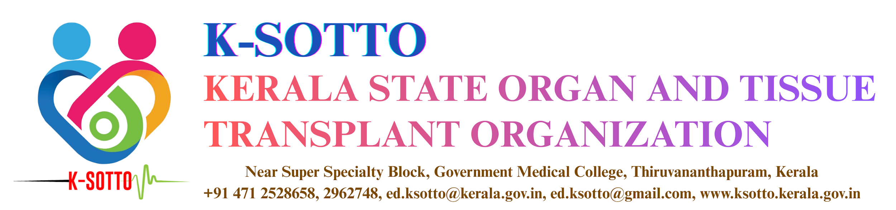
FORM - D3
DECEASED DONOR ORGAN/TISSUE ALLOCATION SUMMARY
(Note: To be filled and sent by the recipient hospital within three days of transplant surgery. Individual forms need to be submitted for each recipient if not multi organ surgery. And also download & attach the recipient registration details from K-SOTTO web portal.)
* Organ/Tissue 2 needs to be filled only in multi organ transplant cases
Date:
No. | Particulars
1. | Recipient Hospital Name
2. | Organ/Tissue Received |  | Organ/Tissue 1: | Organ/Tissue 2*:
3. | Donor Hospital
4. | Donor Name
4. |  |  | Blood Group:
5. | Name of Recipient & Regn. date |  |  | Regn. date:
6. | K-SOTTO ID of Recipient
7. | Date & Time of Organ/Tissue Transplant Surgery |  | Organ/Tissue 1: | Organ/Tissue 2*:
8. | Institutional Waiting List of recipients at the time of allocation
9. | Cross match result / MELD score / Ejection Fraction etc. of recipient as applicable for the case |  |  | Eg: <10% Dead Cells: Negative
10. | Total number of patients in the waiting list prior to the current recipient |  | Active: | Inactive:

11. | Reason for skipping higher ranked patients in waiting list
WL No. | K-SOTTO reg. ID | Recipient Name |  | Regn. Date | Reason | Cross match result/ MELD/ EF as applicable

12. Signature of Transplant Coordinator:

13. Signature of Head of the Department:

Seal:

