|  |
| --- |
| MEDIA REPORT ON DECEASED ORGAN TRANSPLANTATION Date of Donation: 21.07.2020 |
| Prepared by Mr. Vinod Kumar S L Transplant Coordinator, KNOS |
| Report on the Media coverage of Deceased Donor(Mr. Anujith S) from KIMS Hospital, Trivandrum donated on 21.07.2020 |
|  |

|  |  |
| --- | --- |
| **MEDIA REPORT ON DECEASED ORGAN TRANSPLANTATION** Date of Donation: 21.07.2020  On 18th July 2020 afternoon, Dr. Noble Gracious S S, Nodal Officer, KNOS received an alert of a potential brain death patient from Dr. Muraleedharan R, Transplant Procurement Manager, KIMS Hospital, Trivandrum. In view of the current pandemic spread of COVID-19 in our state, KIMS Hospital, Trivandrum took the permission from the Appropriate Authority(DME) to proceed with organ retrieval and transplantation process. The Nodal Officer also informed Principal Secretary, H&FWD, JDME, Principal, Govt. Medical College, Trivandrum (Convenor KNOS) regarding the deceased organ donation through email.  The deceased donor, Mr. Anujith S, age 27 years with Blood group O+ve, worked as a driver with a private company and later joined a supermarket at Kottarakkara as a Salesman after having lost his job due to lockdown. His wife Princy works at a jewellery shop and has a 3 year old son.  On 19th July 2020, after the completion of second Apnea Test, the donor’s wife Princy and the donor’s sister Ajalya gave consent to donate the organs of Anujith and turned savior for seven persons.  As per the Allocation Rules, KNOS allocated The Heart to Lisie Hospital, Ernakulm, Hand and Small bowel was allocated to AIMS, Kochi, One Kidney was allocated to Travancore Medicity, Kollam and the other kidney was allocated to the donor hospital KIMS, Trivandrum. Both the Cornea was allocated to the Regional Institute of Ophthalmology(RIO),Trivandrum,  On 21st July 2020, by 8:30 am,The donor was shifted to Operation Threatre and by 3:30 pm, the organ retrieval was completed.  In the midst of flurry of activity to contain the spread of COVID 19 in Kerala, the heart, hand and small bowel of the deceased patient from Trivandrum was brought to Kochi by a helicopter rented by the State Government. The State Govt decided to use the chopper as an Air Ambulance free of cost to transport the vital organs. This was second such airlifting of the heart in a helicopter during the COVID-19 pandemic outbreak. The organ donation was made possible with the coordinated efforts of the district administrations of Trivandrum and Ernakulam, and the health, police and traffic departments of the two districts. The government’s decision to provide the chopper for the lifesaving mission garnered appreciation from many quarters and was highlighted in all the Medias.  The Hon.Chief Minister of Kerala, Sri Pinarayi Vijayan condoled with the family of the deceased donor Anujith and appreciated his family for their gesture to donate his organs in the live press meet of the pandemic spread update. Honorable Health Minister, Smt Shylaja Teacher, called Princy, wife of the brain dead donor and conveyed heartfelt condolences.  Both the Themes gallery and the Quick Styles gallery provide reset commands so that you can always restore the look of your document to the original contained in your current template. Heading 3 On the Insert tab, the galleries include items that are designed to coordinate with the overall look of your document. You can use these galleries to insert tables, headers, footers, lists, cover pages, and other document building blocks. When you create pictures, charts, or diagrams, they also coordinate with your current document look. |  |

# MINUTES OF THE MEDIA REPORTING COORDINATION

**Day 1: 21.07.2020**

* At 8:58 AM : Dr.Noble informed to coordinate the Media reporting and shared the contact details of Premchand, the family friend of the deceased donor.
* At 9:15 AM : Contacted Premchand, the family friend of the deceased donor and asked to be a mediator to talk to the bereaved family to get consent from his wife and close relatives to report the news in the Media.
* At 9:30 AM : Premchand conveyed the acceptance of the family members and shared few pics of Anujith, the deceased donor and the newspaper cuttings Anujith had made headlines in 2010 for his timely intervention to avoid a train accident.
* At 9:35 AM : Informed the news to the PRO of the Health Ministers’ office, Mr. Prasannan and reported the news to all the leading Malayalam Television News Channels- Malayalam Manorama, Mathrubhumi, Asianet News, Kairali News, Jaihind etc about the donation of 8 organs of Anujith and airlifting of the vital organs from Trivandrum to Ernakulam which KNOS allocated as per the Allocation Rules.
* At 12:30 PM: Premchand took a video and shared us the video clip of Princy, wife of deceased donor regarding the message she wanted to tell the world and the reason behind the humanitarian step of donating the organs in the time of grief.
* At 12:45 PM: Shared the pics and video clips received to the PRO of the Health Ministers’ Office, Mr. Prasannan to prepare the matter and content of the news to send across the print media.
* At 3:30PM: Received the matter to be published in the newspaper from the PRO of the health Minister and the news was conveyed from the Health Ministers’ office to the print media.
* Coordinated with the entire news coverage the entire day and gave the information about the donation and contact details of the donor family.

**Day 2 : 22.07.2020**

* At 1:00 PM : Autopsy was done at Government Medical College, Trivandrum. We waited at the hospital until the entire process was completed.
* At 2:00 PM : The donor body was handed over to the donor family.
* At 4:00 PM : Cremation was held.
* At 5:00 PM : Premchand shared the pictures of the cremation held at Anujith’s residence at Kottarakara.
* At 5:10 PM : News regarding the same was reported to Mr. Sajeevan, PRO of Government Medical College, Trivandrum to report the news to the media. The news was shared to all the leading Malayalam Television News channels and Newspapers( local edition, state edition and national edition)

# **PRINTED MEDIA COVERAGE**

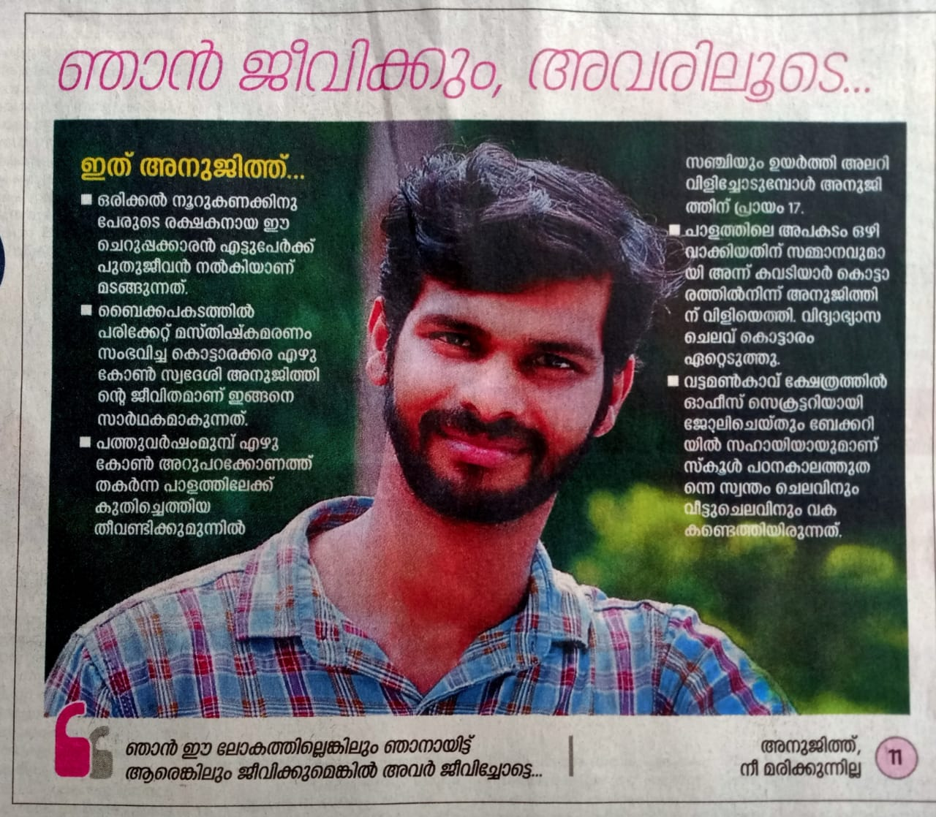

Mathrubhumi 22nd July 2020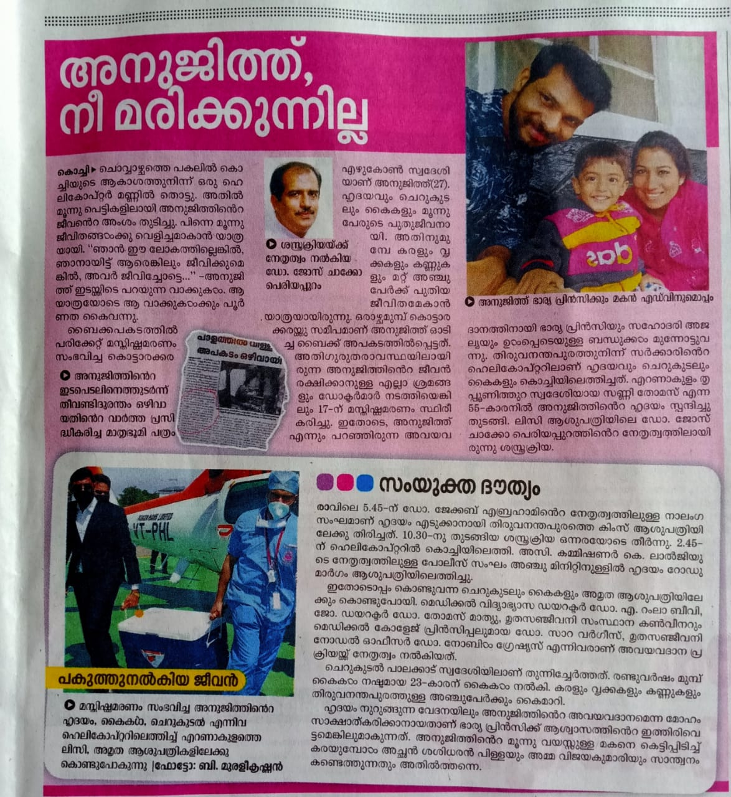

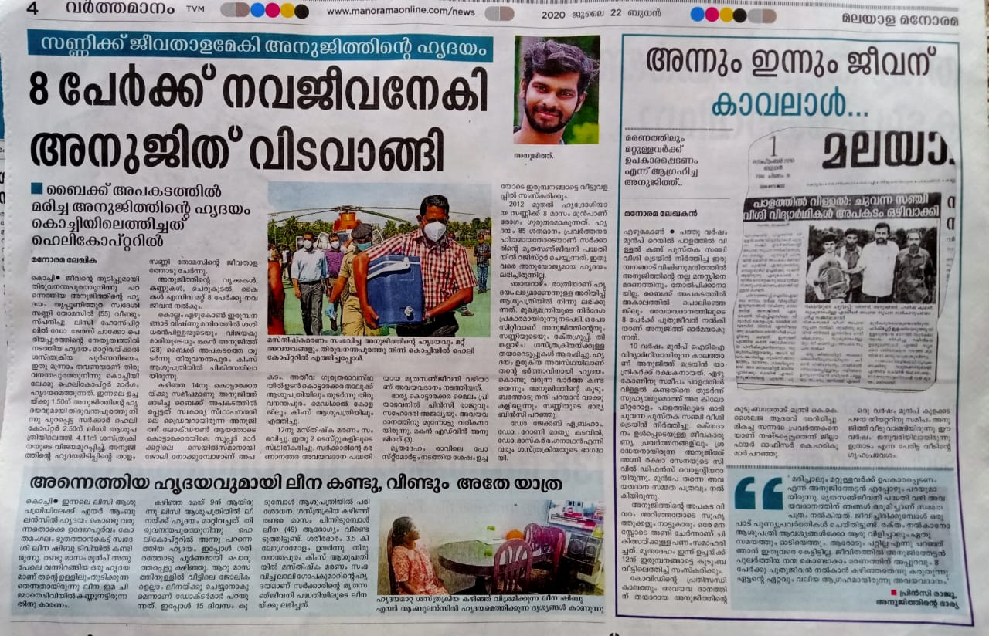

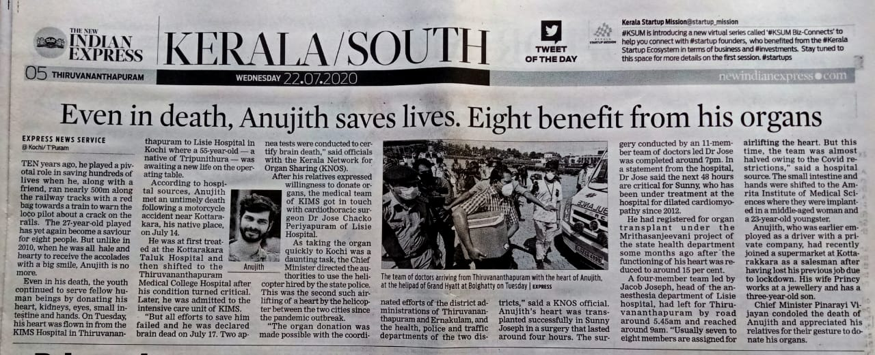

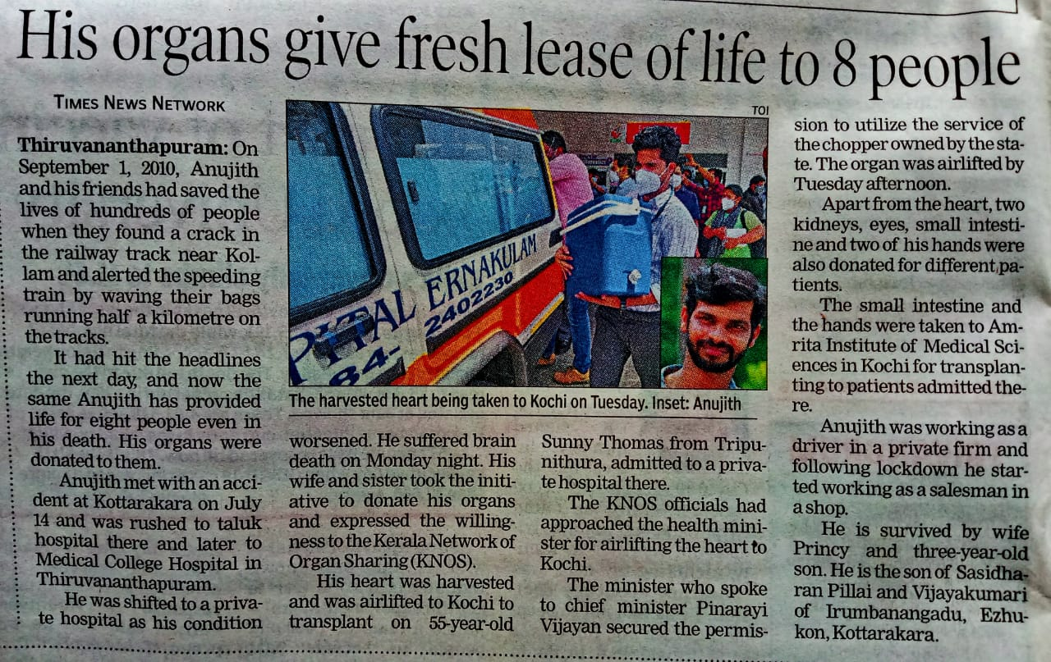

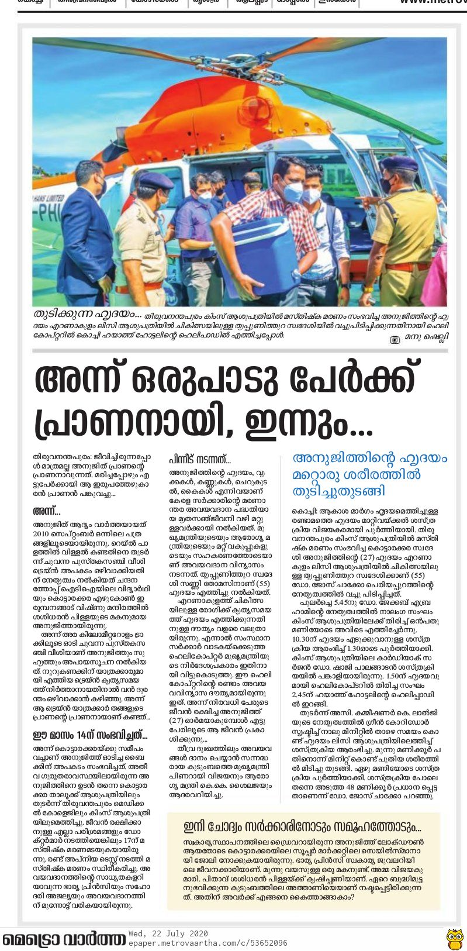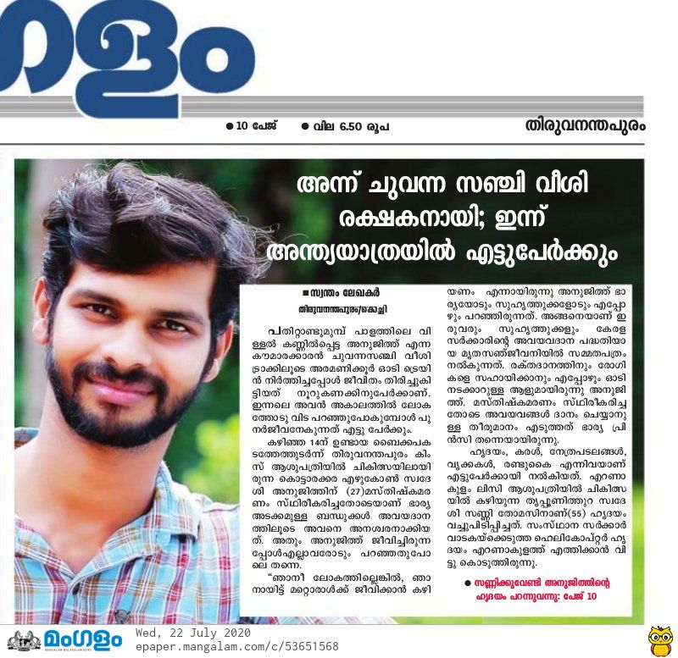

X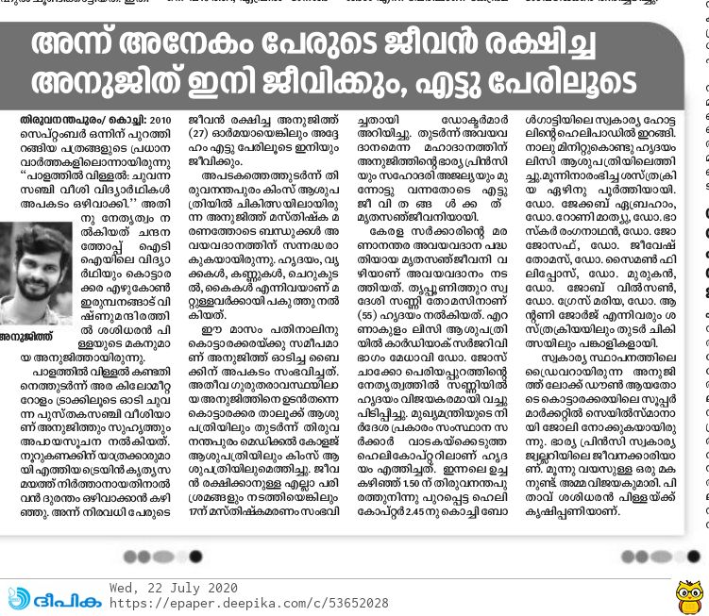 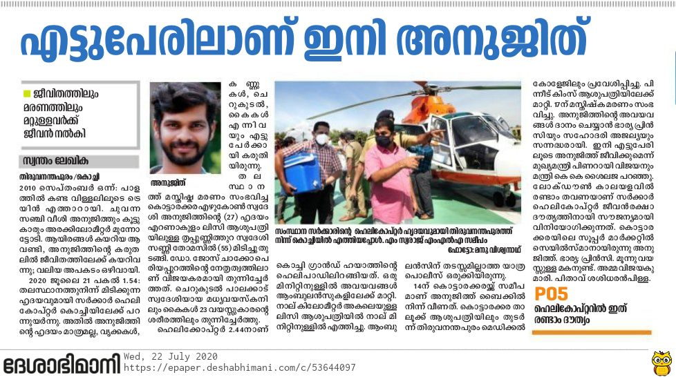 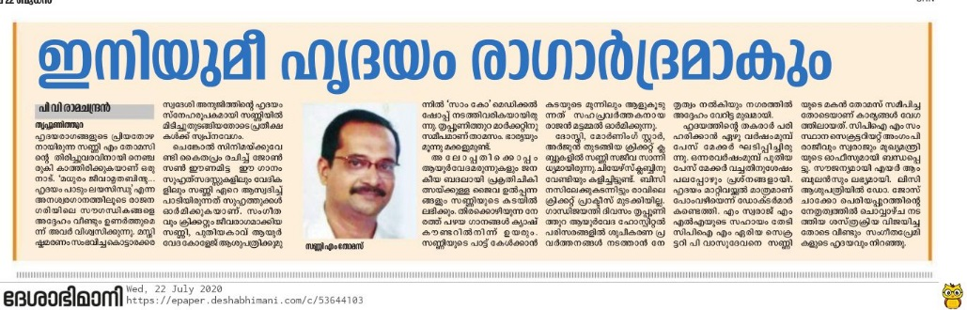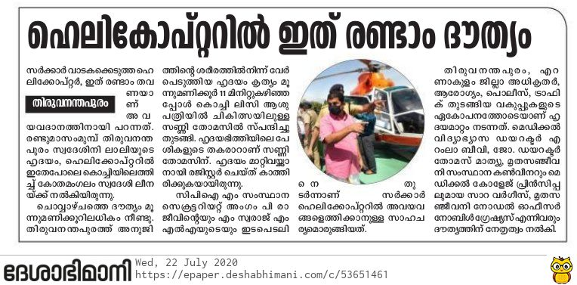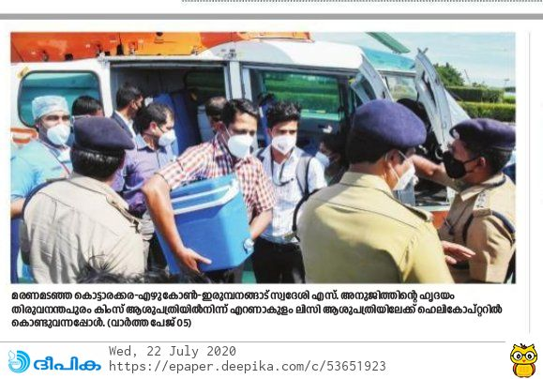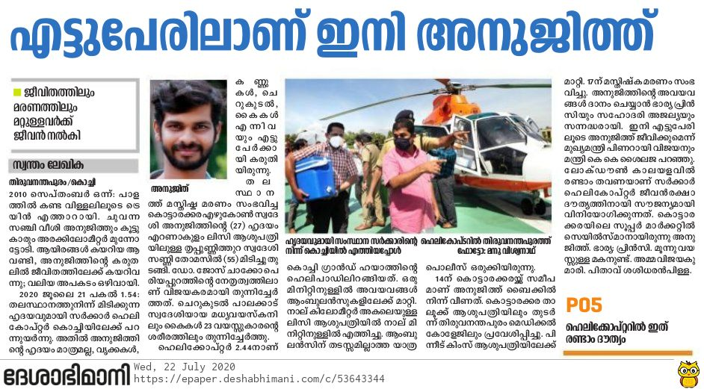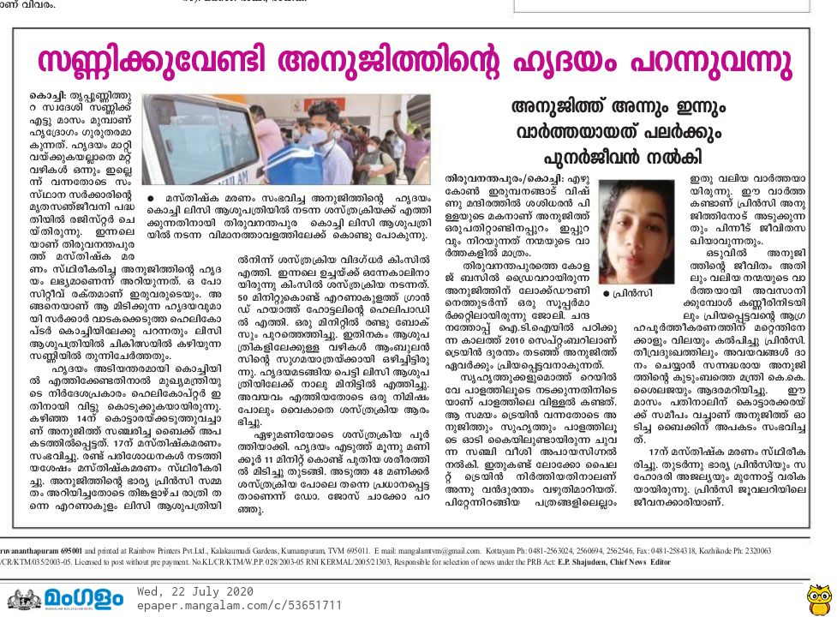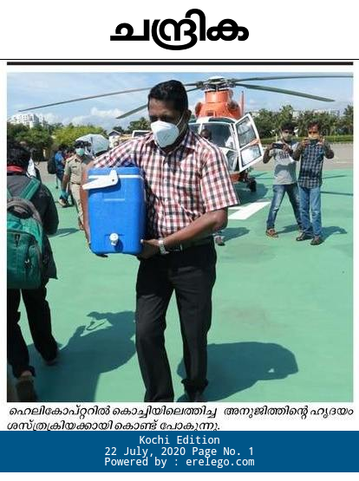

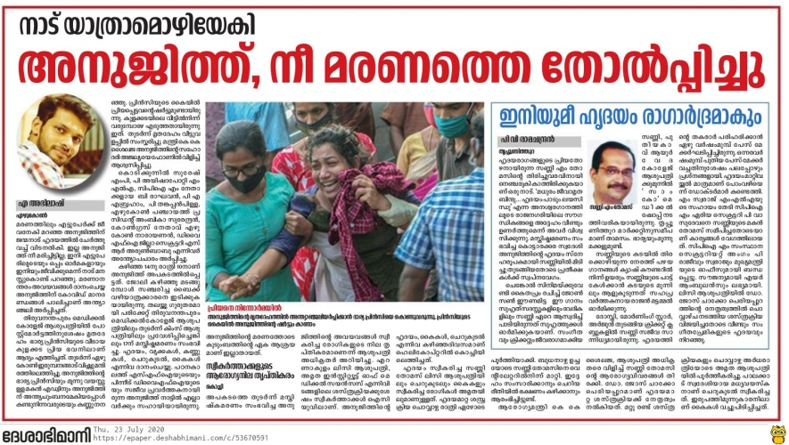

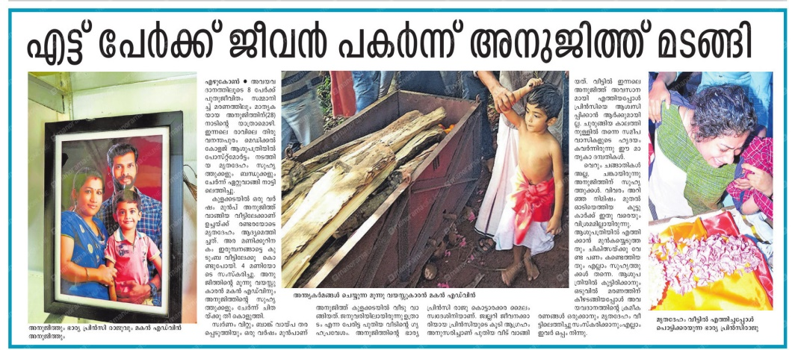

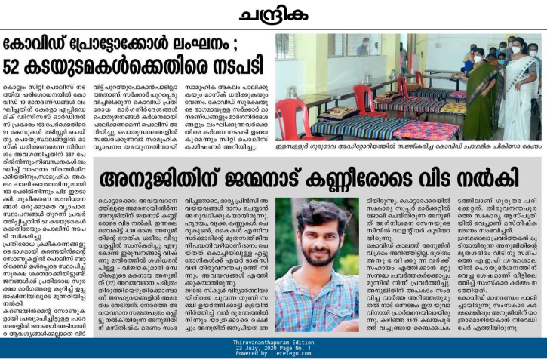

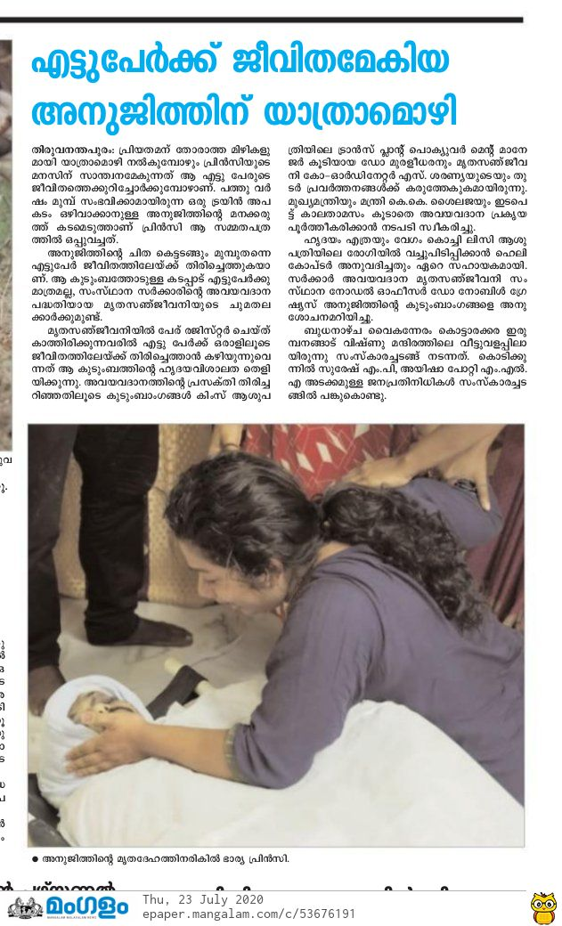 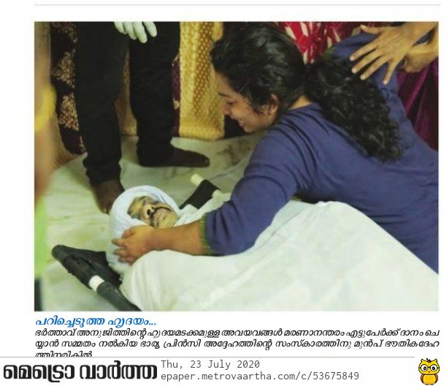

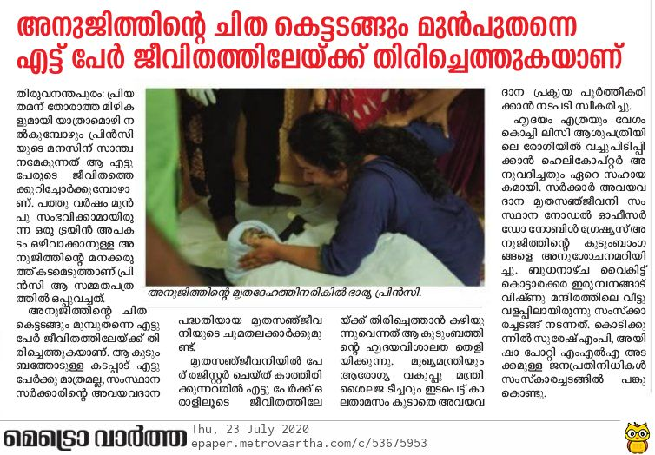

# **TV COVERAGE screen shots**

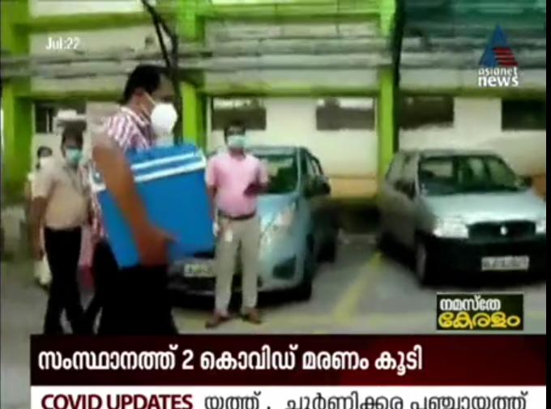 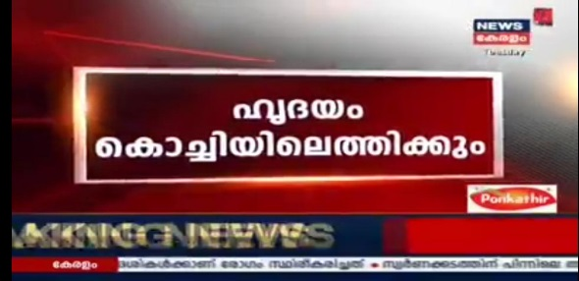 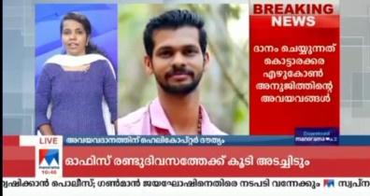 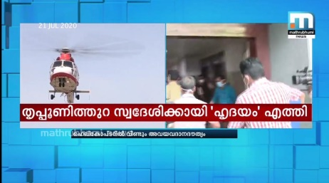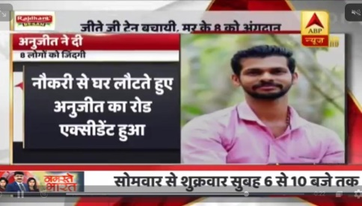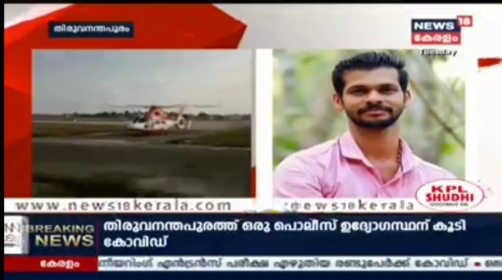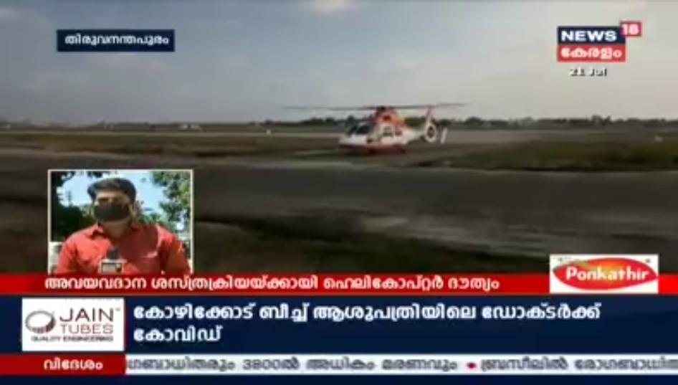 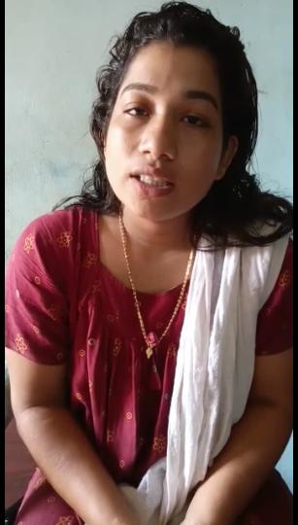 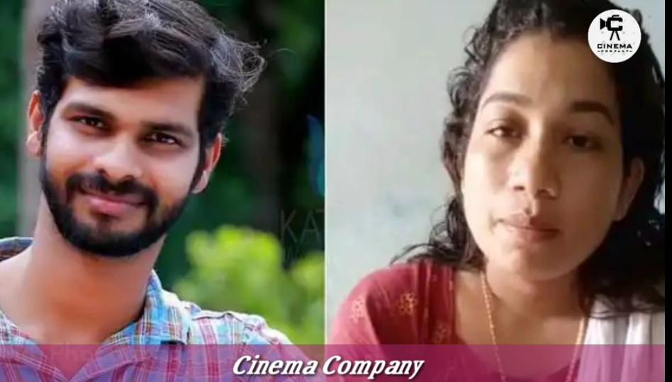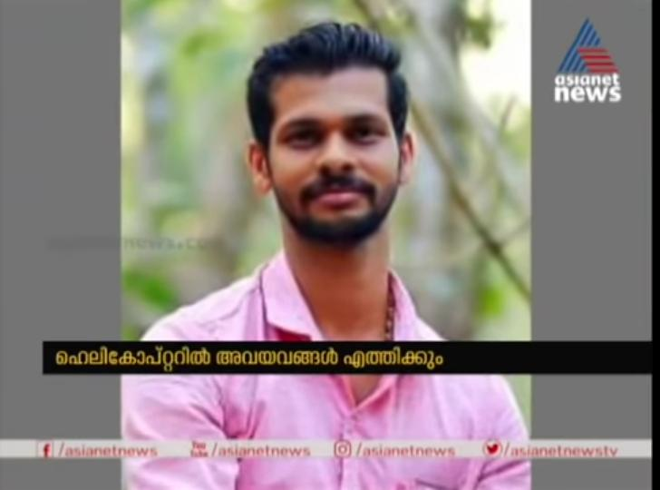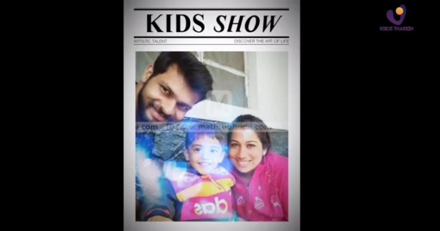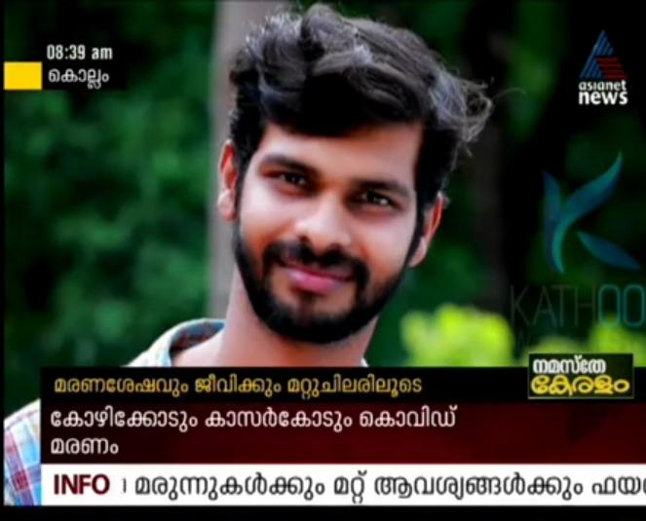 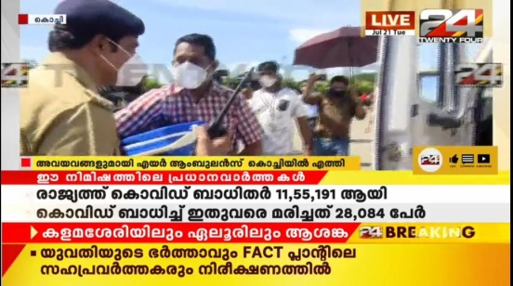

# **WEB NEWS LINKS of the news coverage nationwide:**

|  |  |  |
| --- | --- | --- |
| |  | | --- | |  | |  |

* <https://zeenews.india.com/tamil/india/kerala-young-man-became-hero-in-life-and-death-by-organ-donation-339097>
* <https://www.patrika.com/miscellenous-india/27-year-old-anujeet-becomes-an-angel-for-eight-people-even-after-dies-6287134/>
* <https://eisamay.indiatimes.com/nation/kerala-man-who-once-saved-hundreds-of-people-in-2010-saved-eight-more-after-death/articleshow/77107111.cms>
* <https://www.manoramaonline.com/news/latest-news/2020/07/21/anujith-s-organs-donated-to-8-people.html>
* <https://www.manoramaonline.com/news/latest-news/2020/07/21/anujith-heart-transplant.html>
* <https://www.deccanherald.com/national/south/kerala-youth-who-once-averted-train-mishap-gives-fresh-life-to-8-through-organ-donation-864163.html>
* <https://www.deccanherald.com/national/south/youth-gives-life-to-eight-through-organ-donation-864827.html>
* <https://www.mathrubhumi.com/news/kerala/anujith-s-family-give-consent-to-organ-donation-1.4920422>
* <https://malayalam.indianexpress.com/kerala-news/organ-donation-anujith->

mohanlal-phone-call-399037/

* <https://zeenews.india.com/tamil/india/kerala-young-man-became-hero-in-life-and-death-by-organ-donation-339097>
* <https://bengali.abplive.com/news/kerala-youth-gives-fresh-life-to-8-through-organ-donation-once-averted-train-mishap-719406/amp>
* <https://www.manoramaonline.com/news/kerala/2020/07/22/heart-transplant-women-leena-shibu-watch-ajith-organ-donation.html>
* <https://www.patrika.com/miscellenous-india/27-year-old-anujeet-becomes-an-angel-for-eight-people-even-after-dies-6287134/>
* <https://eisamay.indiatimes.com/nation/kerala-man-who-once-saved-hundreds-of-people-in-2010-saved-eight-more-after-death/articleshow/77107111.cms>
* <https://www.madhyamam.com/kerala/anujith-organ-donation-story-kerala-news/700398?utm_source=whatsapp&utm_medium=referral>

**XXXXXXXXXXXXXXXXXXXXXXXX**